Project Report

**Team information**

Team number 11, composed of Daniel Esparza, Tyler Fenske, and Justin DeSalvo, created the game “Wifi Hero”. Justin created the splash screen, the choose a difficulty screen, the end game screen, as the move/wraparound functions and objects on the screen where the game is played. Tyler created the calculations for the scores, the high scores page, and the read/write for the high scores text file.

**Statement of the problem, significance**

The objective was to create a game involving a varying amount of satellites displayed on a map. The player would accumulate points by moving the satellites furthest away from each other and the game ends when all moves have been used. This project is significant because it gave us the experience of building our own game from beginning to end. It also teaches teamwork and allowed for creativity on the student’s side.

**Restrictions and limitations**

We were mostly limited by our own skills, this caused for a lot of referencing to the book and fltk documents online. One other limitation was the amount of reference documents for fltk and lack of community to call on for assistance. For one problem, the latest solved question online was from 2004 and had little to offer to our problem. Finally, the bug with the widgets caused for us to include button covers to show where the original widget was placed, and when the bug was fixed it caused a variety of problems and caused us to revert to the original bugged version.

**Explanation of your approach**

Upon reading the instructions we realized that it would be best to implement a modular like design to our code. This would allow for easy transition from any screen to a previous one. It was decided that just detaching and reattaching functions for each screen would allow for easy movement from screen to screen as well as an easy loop back from the end of the game rather than destroying screens completely and creating a new one. Also we do not have to have a bunch of different windows, but just one window that changes continuously which simplifies our main. Comments were use to divvy up code for the different screens and parts of the screens. Functions and variables that are similar for different screens were named uniformly to avoid confusion, but numbered to avoid renaming.

**Sample Run**

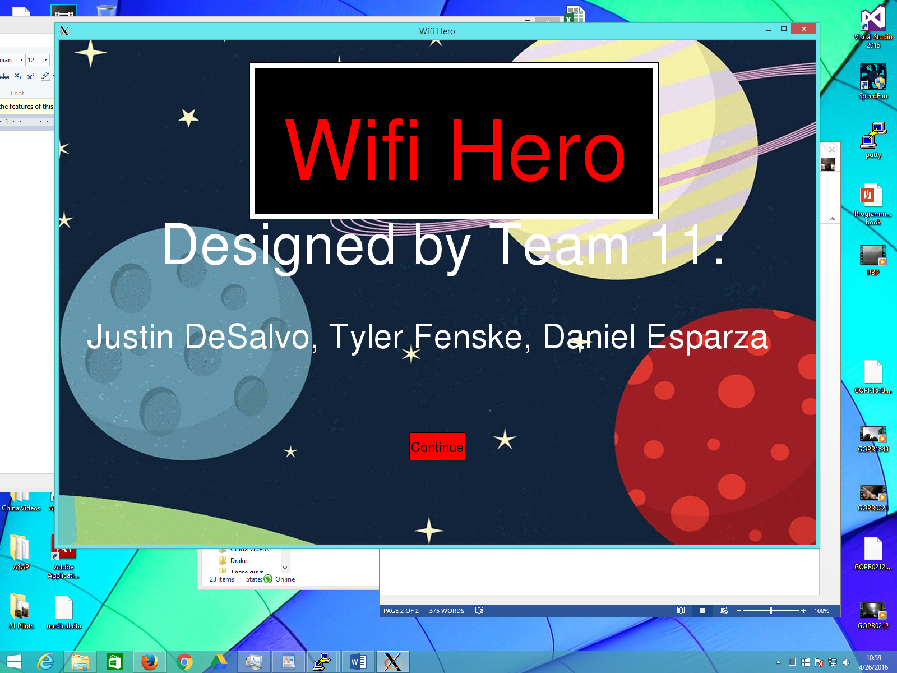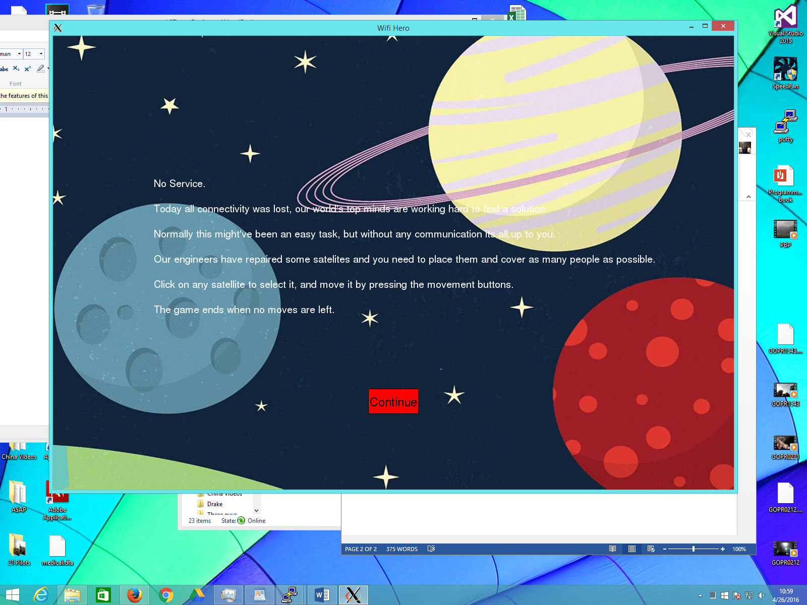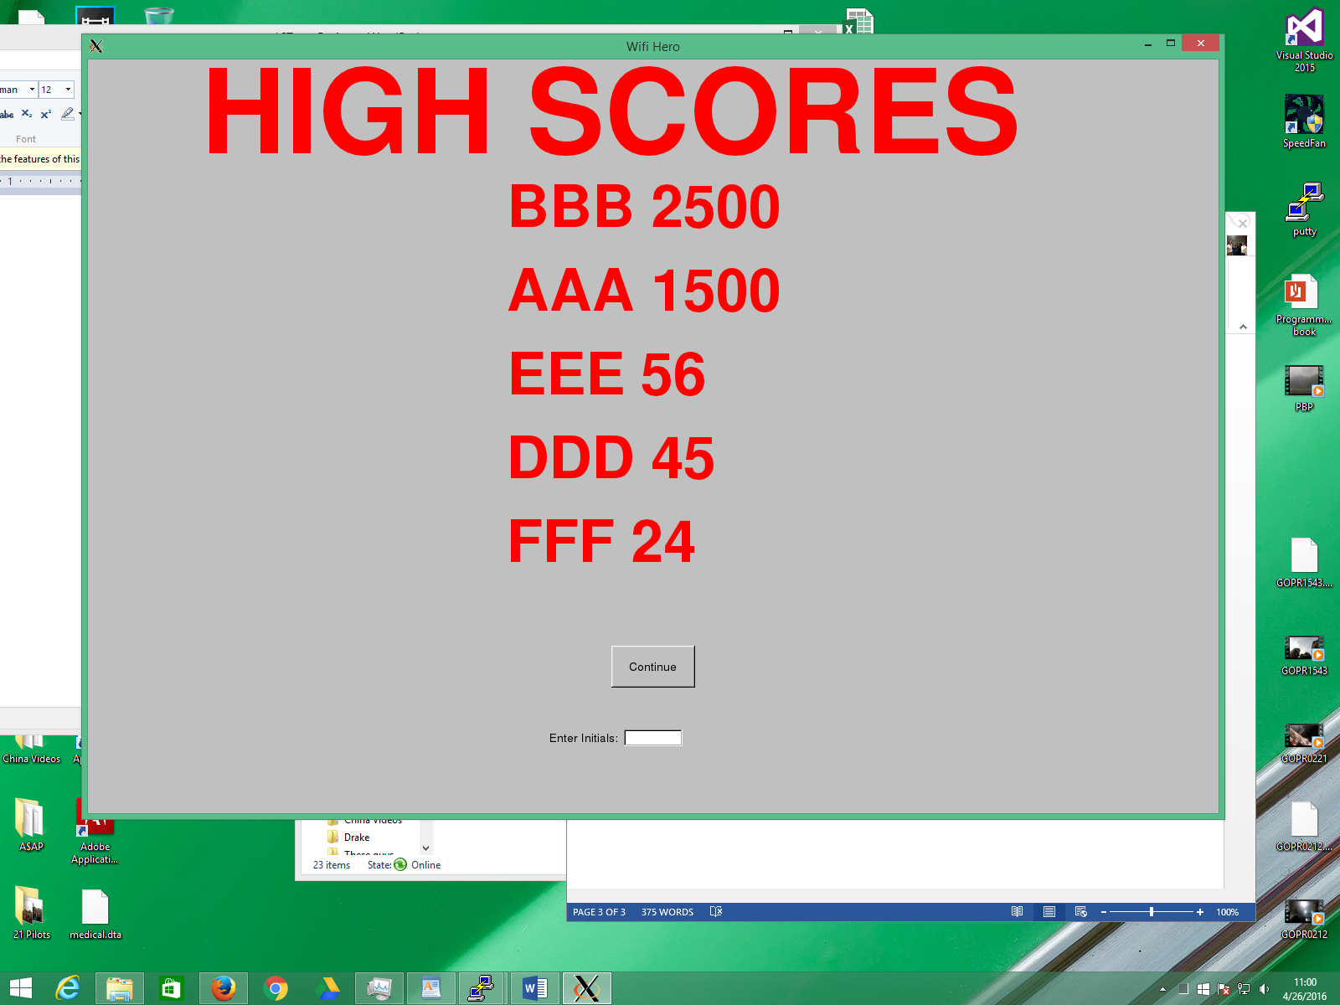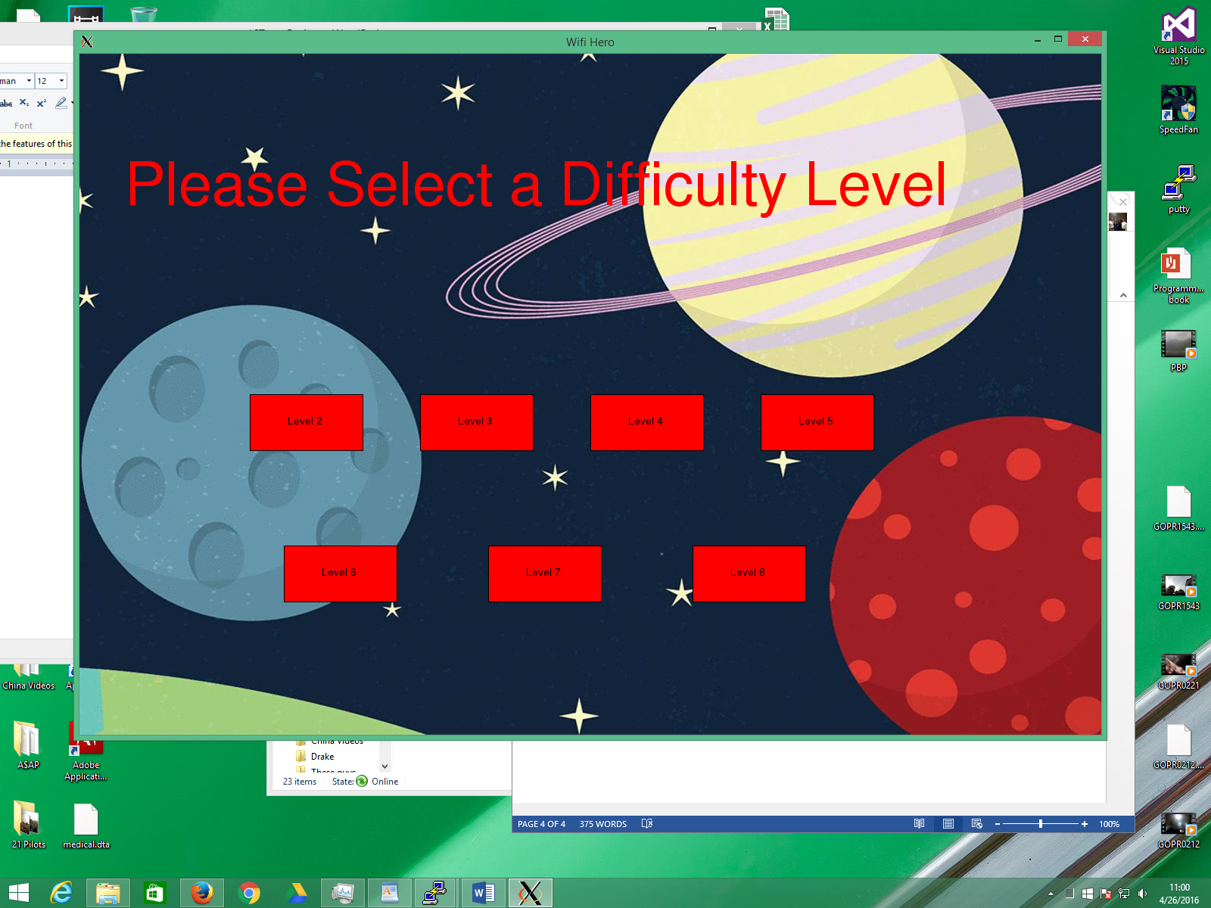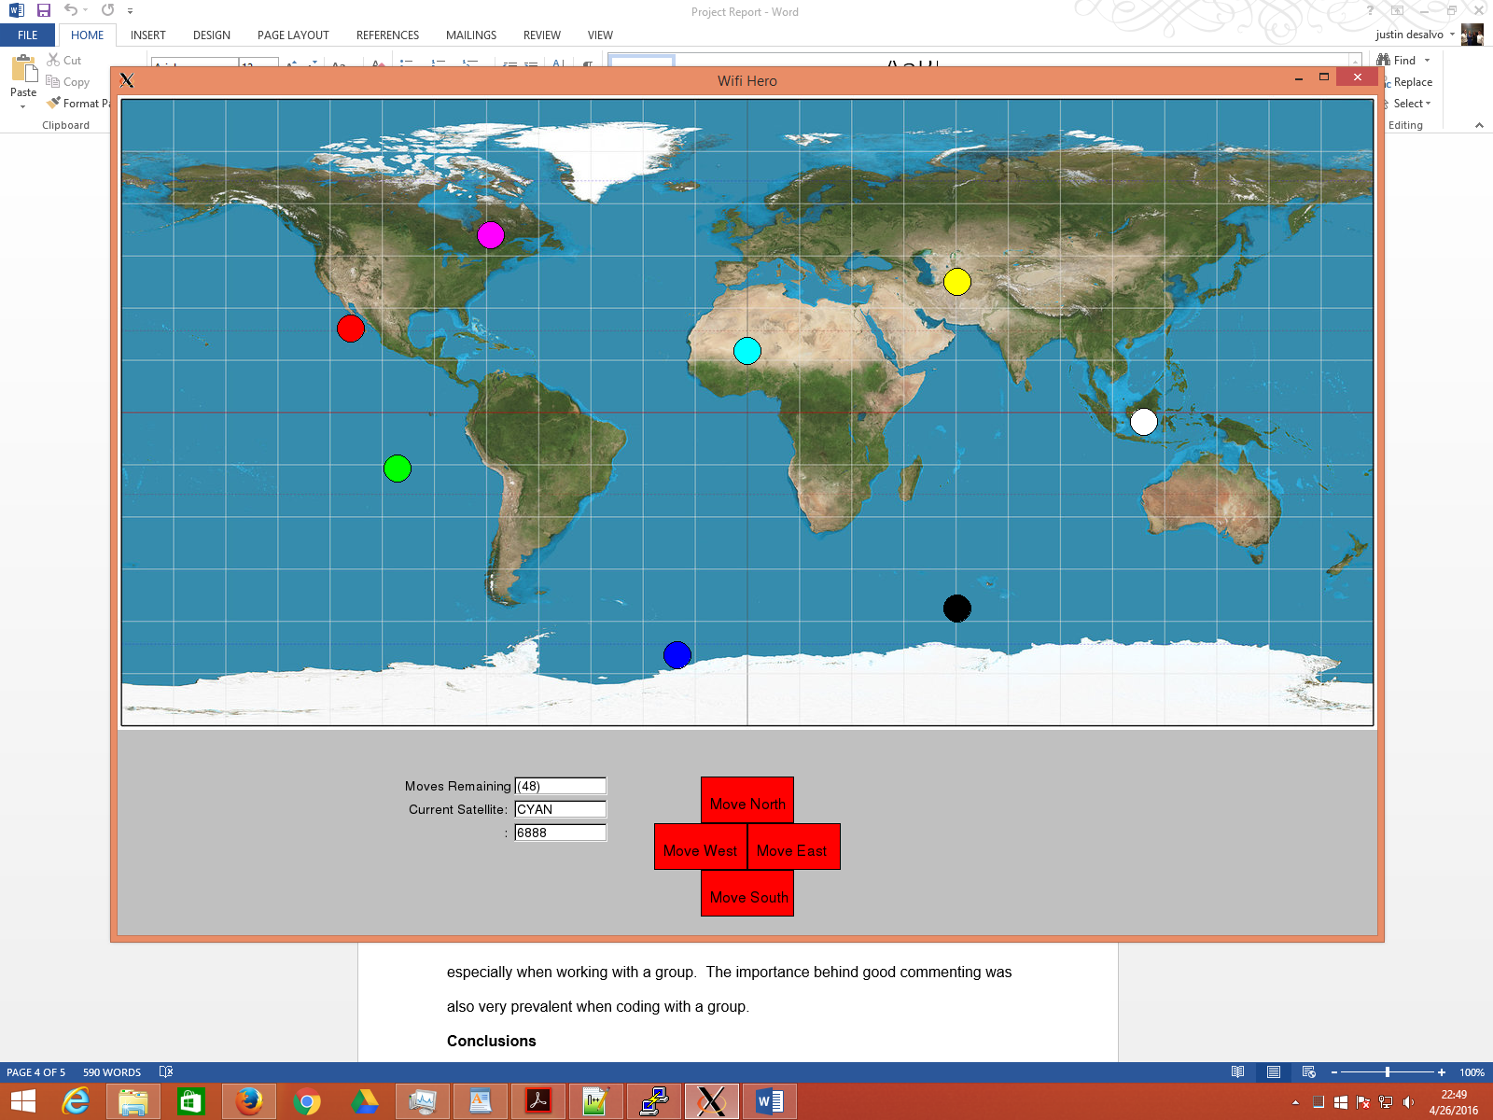

**Results and Analysis**

This game proved to be difficult as fltk was very buggy when pushing buttons, and was even worse when changed to draw widgets on top of the objects. As much planning as possible is best before as you will run into issues and often have to go back and fix them later if you do not account for them to begin with. Timeliness is important, especially when working with a group. The importance behind good commenting was also very prevalent when coding with a group.

**Conclusions**

The importance uniform coding is when coding with other people is huge. The idea that others need to be able to read your code, understand your code, and work with your code is very useful in a group setting. The possibilities for a way to do something through code are endless, the importance is being able to simplify it and make it more comprehensible.

**Future Research**

The program could be improved with a better graphics package that was less buggy when drawing in widgets and objects together. With more time, there could be simplification of the code within our program. Also we could have added features such as making the game look more 3 dimensional and making the satellites look more like satellites.

**Running The Program**

The program is run through an a.out file that is included in the contents of the folder.